

**Team Members**

**Faculty: Miss Fariha**

**Name Student ID Role**

Akhtar Hameed 1376876 Home Page and Documentation

Khurram 1372341 Top 5 cities in world and contact us

Ahmed N/A Today in world, sports and about us

**Problem Statement:**

DNBC is a well-known brand in news and reporting. Around the world, they have a network of reporters. All news pieces are gathered and sent to the London headquarters. The news is then prepared by the main office and published in the newspaper in the appropriate segments. The company is currently preparing to build a website in order to make news available to readers and subscribers more quickly. As a result, information and news will be sent more quickly, and readers will be able to search for and read news from anywhere. They want the website to offer a user-friendly atmosphere and navigation. The key menu needs to be visible in the webpage's header. Additionally, a respectable appearance and color scheme are desired

**Flow Chart:**

**Home**

**navigation**

**Latest Trend**

**Footer**

**Featured News**

**Website’s Screenshots**

**Navigation:**

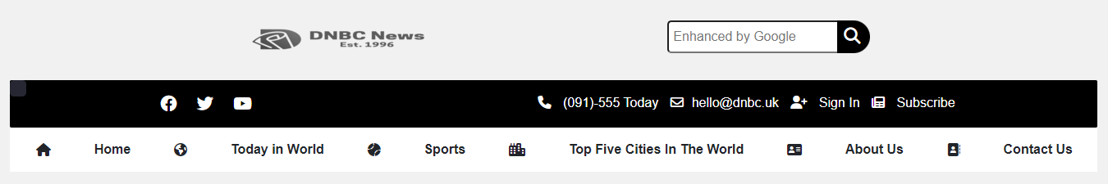

**Page Layout:**

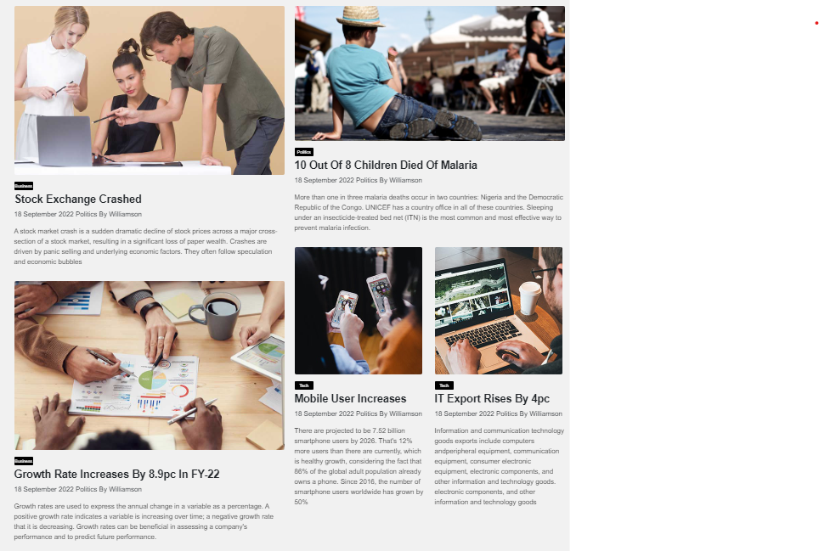

**Editor’s Choice**:

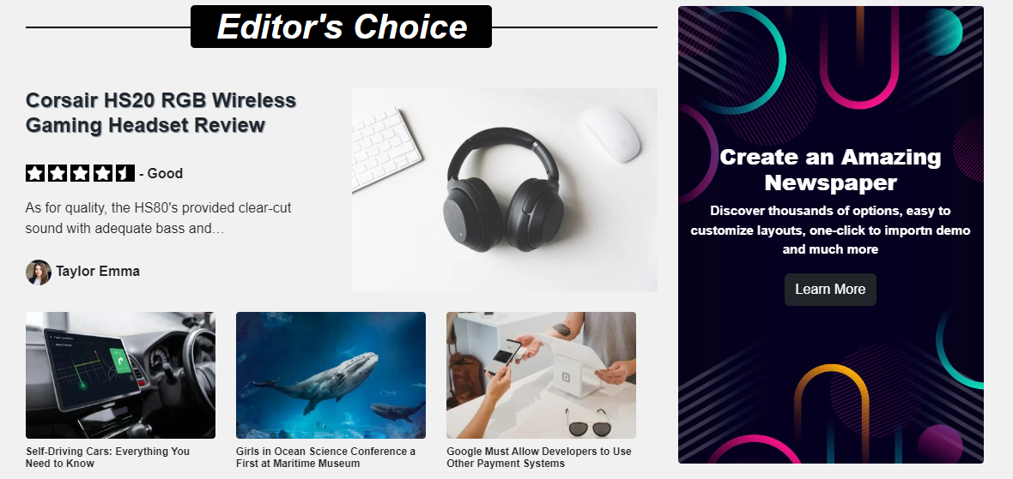

**Featured News:**

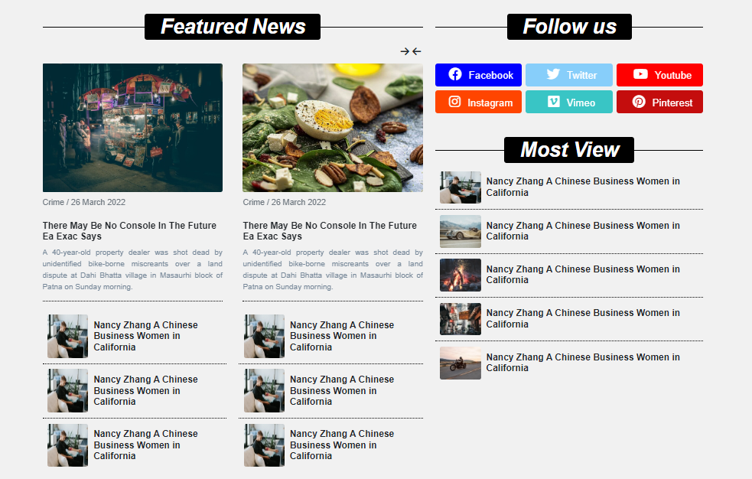

**Latest Trends**

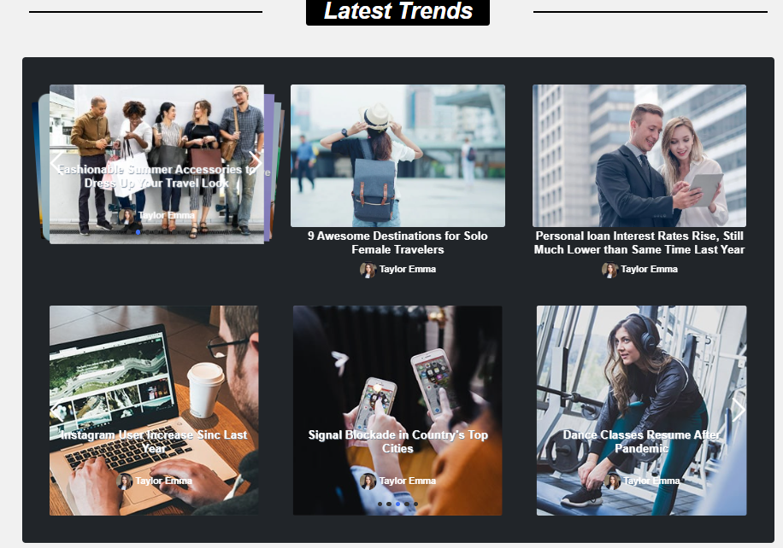

**Client’s Review:**

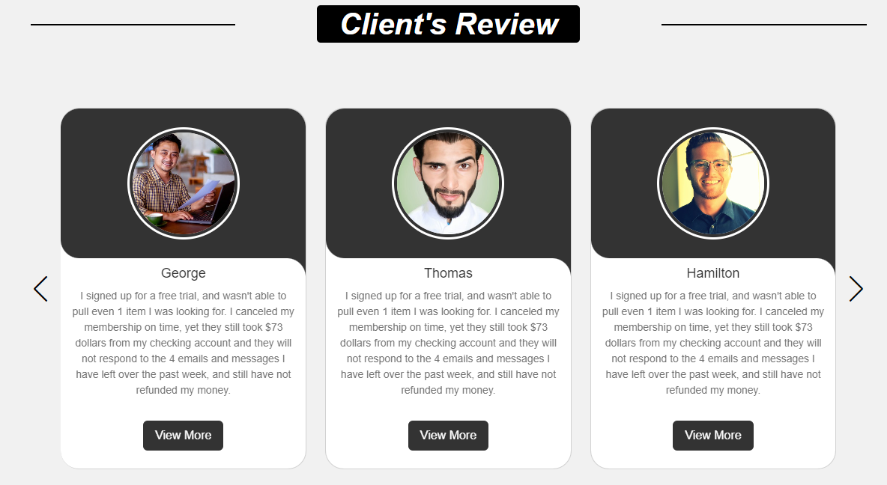

**Footer:**

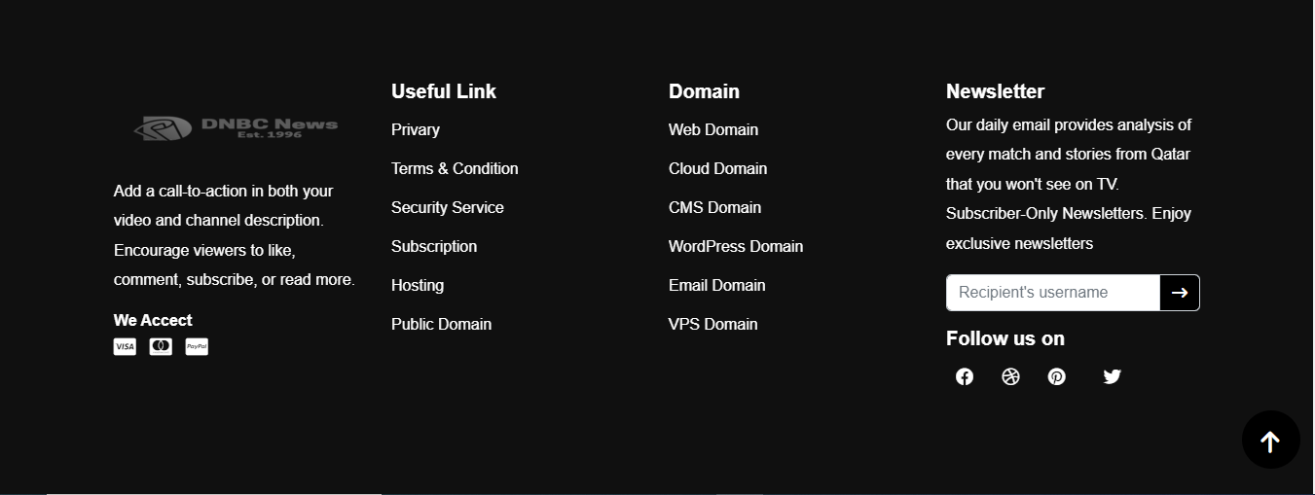

Navigation coding source code

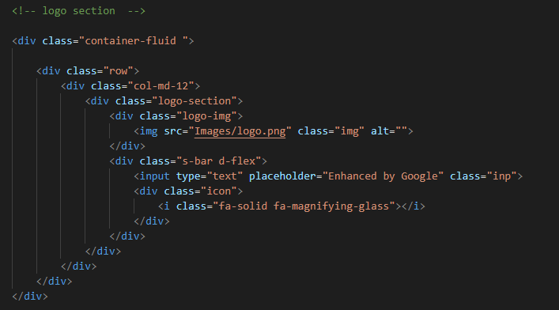

**Page layout:**

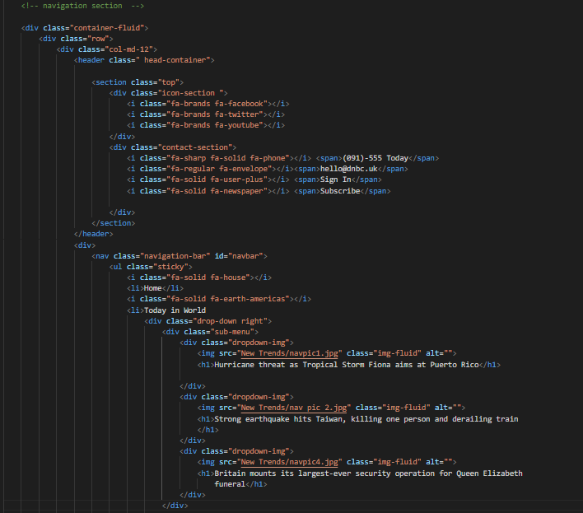

**Editor’s Choice:**

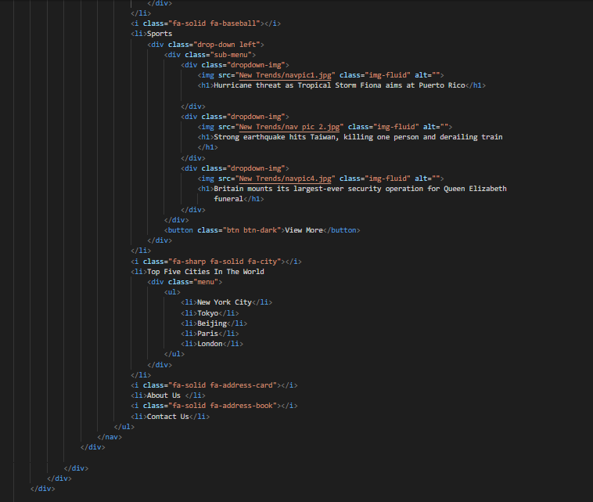**Latest Trends source code**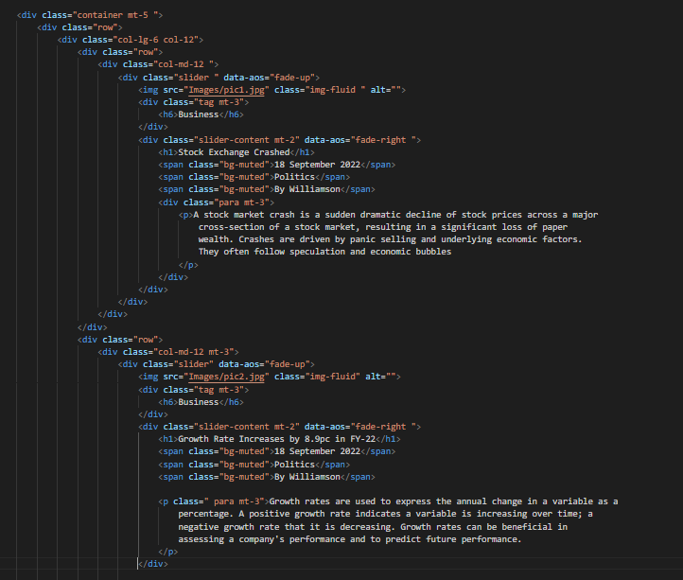

**Featured news source code**

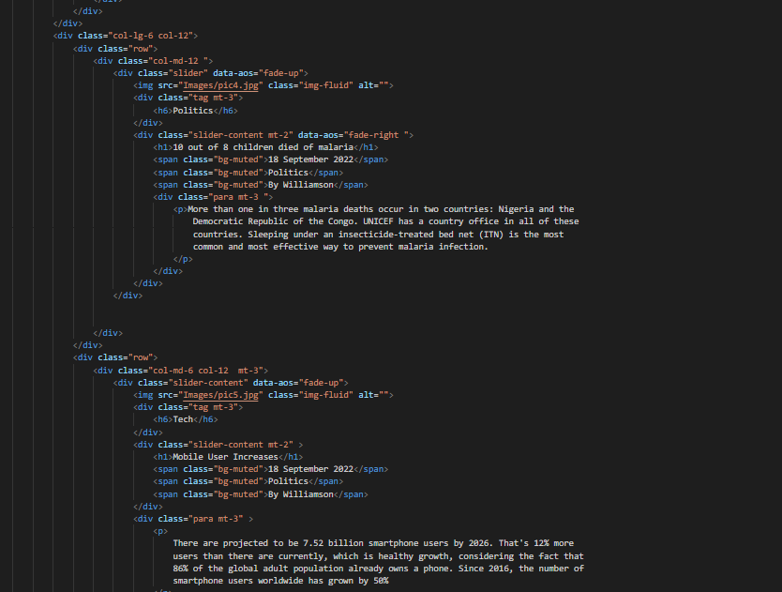

**Footer source code**

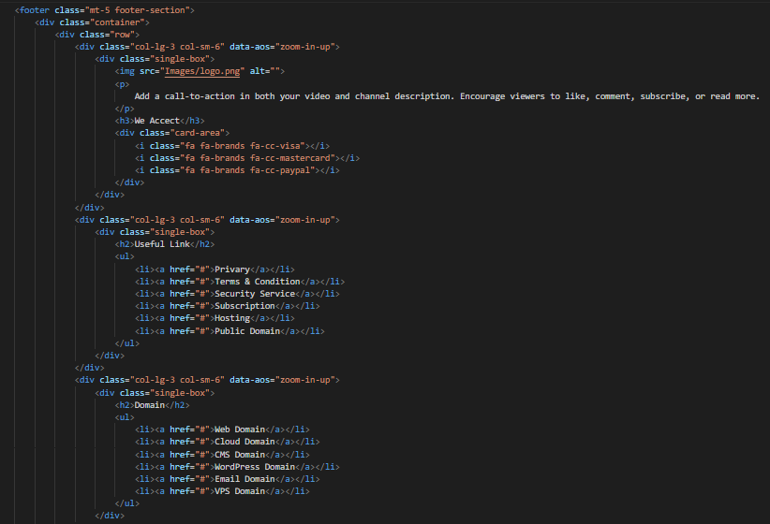

Website’s Specification:

|  |  |
| --- | --- |
| Technologies | HTML 5, CSS3, JavaScript |
| CSS Framework | Bootstrap, Swipper.css, AOS.css |
| Font Family | Sans-Serif |
| JavaScript Plugins | AOS.js, Swipper.js |
| Responsive | Yes |
| User Friendly | Yes |
| Start From | 20 Oct 2022 |
| End in | 20 Nov 2022 |